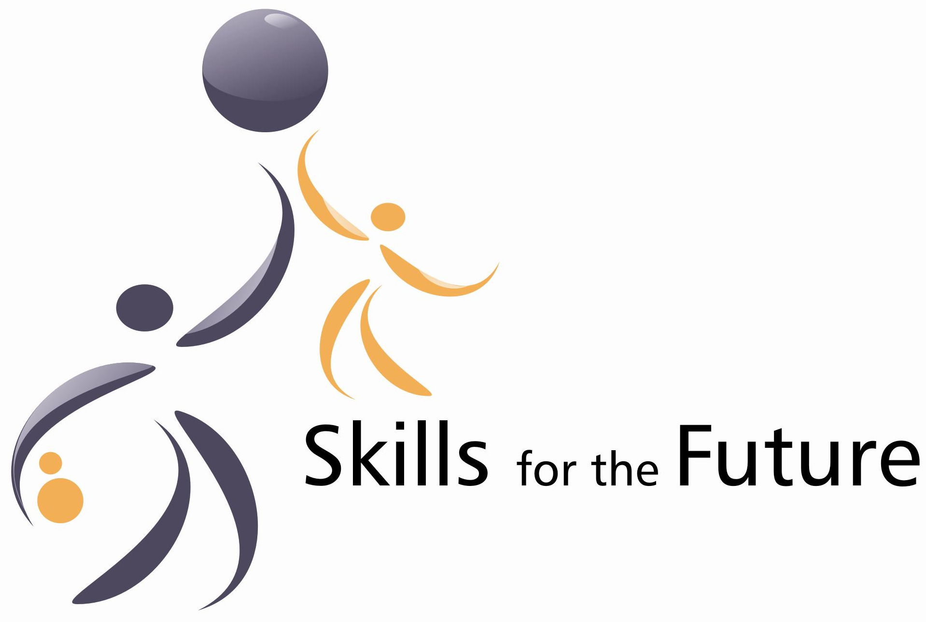

TEST FOR THE BEST. EUROPEAN SKILLS ACHIEVEMENT CONTEST
Contest Goals
The competitiveness of European Enterprises is strongly dependent on the quality of the human capital. Human capital is critical for the development of European economy. Only when students and graduates of higher education institutions gain attitudes and skills really valuable for enterprises, the business sector can develop dynamically. Our first key goal is to reduce differences in enterprises expectations and educational services provision by showing higher education institutions what is really needed by the business sector. The contest questions and exercises are reflecting real needs of enterprises and the level of those needs fulfillment will be checked during this contest. We foresee that dynamically managed higher education institutions can benefit directly from this contest.
Our second key goal is aimed at highly motivated young people, who want not only pass all formal exams to receive graduation, but who want really contribute to the business sector development in Europe. By attending this contest they receive prestigious certificates being the evidence to the employers how really they are prepared to work in enterprises. We foresee that the European Certificate on Skills Achievement can be a valuable instrument facilitating employment of young people and turning their interests on those areas which are really needed by enterprise sector.

Contest Rules
- Definitions and general arrangements
- The Contest is organized within the framework of Erasmus funded project: Skills for the Future SKIFF. Lifelong Learning Programme, DG Education and Culture.
- The Contest is organized by: 1) Institute for Private Enterprise and Democracy – IPED (Poland) , 2) ERIFO (Italy), 3) Gestao Total (Portugal), 4) Ahi Evran University (Turkey).
- The contest will be directed to three educational spheres: management and economics, engineering, business services (finance, advertising, bookkeeping, legal services etc.).
- The contest is organized in 4 countries: Poland, Italy, Portugal and Turkey. All Students studying in EU, EU associated or candidate countries may participate.
- The official name of the contest is in English: TEST FOR THE BEST. EUROPEAN SKILLS ACHIEVEMENT CONTEST. Organizers can use the second name of the contest in their national languages in the following forms: Polish name of the contest is: TEST FOR THE BEST. Europejski Test Umiejętności Przedsiębiorczych; Italian name of the contest is: TEST FOR THE BEST. Concorso sul possesso delle competenze richieste dalle imprese europee.; Portugese name of the contest is: TESTE PARA OS MELHORES ; Turkish name of the contest is: En iyiyi seçiyoruz: Avrupa beceriler yarışması.
- The contest will check the level in which the last year (or term) students of bachelor or masters levels, achieved the skills and attitudes needed by enterprise sector.
- The level of achievement will be measured in percentage, while 100% will be the maximum rating and 0% will be the minimum rating.
- The test examination will be conducted in national languages of Poland, Italy, Portugal and Turkey.
- Responsibility for the contest in the 4 respective countries is performed by 4 national organizers mentioned in the point 2.
- Overall coordination of the contest is performed by IPED, Poland.
- Contest organization
- The recruitment of students for the contest is open, available for all students and based on the first come rule. Within the scope of SKIFF project duration, the contest is free for students and costs are covered by the organizers from EU sources and own resources.
- The minimum number of participants of the contest is 50 and the maximum number is 180 in each country.
- The national organizers announce the contest on the Internet, and inform higher education institutions in the project spheres (see point 4 Section A) in the respective countries
- The participants of the exam should register on the web pages (www.iped.pl, www.erifo.org, www.gestaototal.com, www.ahievran.edu.tr) of national organizers or using electronic forms.
- The examination will be in the form of written test.
- The contents of the test is kept in the secrecy and national organizers assure that the questions will be revealed only on the examination meeting.
- Organizers provide the sample test for orientation of contest participants. The samples will be prepared in national languages of Poland, Italy, Portugal and Turkey and will be located on the project organizers web pages openly.
- The examination is to take place in 4 respective countries and last 120 minutes. No prolongation can be assured in any country.
- The national organizers in 2 weeks evaluate the written tests and announce the results to the general public. Announcement should include listing by names the alumni, who passed the test and 3 the best schools represented in the contest in the each country. Announcement should be done on the contest organizers web pages. Information on the general results should be forwarded to the press and other media.
- All participants receive numbered certificates from national organizers.
- Passing the test requires minimum 60 points.
- On the conclusion of the contest each national organizer will organize an event of awarding TEST FOR THE BEST certificates to all students who passed the test. Three the best winners in each respective country will receive Awards of Excellence and one, the best in each country will be invited to project assistantship (paid project service) by national contest organizers.
- Verified Skills and Attitudes
1. During the Contest Organizers will verify following skills and attitudes:
1.1. Attitudes: 1) respect for the others; (2) honesty – personal ethics; (3) loyalty to the company; (4) willingness to take tasks; (5) time flexibility; (6) personal mobility; (7) responsibility taking; (8) willingness of sharing own knowledge and experience; (9) openness to the others’ problems; (10 ) collaboration with other employees.

1.2. Skills: (1) Communication; (2) Team work; (3) Problem solving; (4) Initiative and enterprise; (5) Planning and organizing; (6) Self awareness; (7) Learning; (8) Workplace skills.

- Final provisions
- Participants are not entitled to question the results of the examination nor ask for new chance for examination.
- Organizers act in their best will and will act openly, providing equal chances for all contest participants.
- Higher force (vis maior) excludes responsibilities of contest organizers.
- The contest rules are translated into national languages of 4 respective countries. In the case of doubt on the contest provisions, original English text will be accepted as only valid.
- National contest organizers listed in section A are entitled to conduct the contest with support of other organizations, especially higher education institutions, who can be tilted Contest Co-organizers.
- The contest can be continued after termination of the SKIFF project, providing that all costs of it are covered by participants and sponsors.

